ST. STEPHEN’S SCHOOL
PHYSICS 2A

END TOPIC TEST
NUCLEAR PHYSICS

Name:

Teacher:

INSTRUCTIONS

- You have 50 minutes to complete the test.
- It is recommended that you take a few minutes to read the paper through carefully.
- Answer all questions in the space provided.
- Use BLACK or BLUE pen only.
- Scientific calculators are permitted for this test (NO GRAPHICS CALCULATORS).
- Unmarked physic constant sheets are permitted for this test
Test Score:

50

Percentage:

POST ASSESSMENT REVIEW
(to be completed upon return of your marked paper)

Which topics / questions did I do best at?

________________________________________________________________________
________________________________________________________________________
________________________________________________________________________
________________________________________________________________________

Which topics / questions could I have improved on?

________________________________________________________________________
________________________________________________________________________
________________________________________________________________________
________________________________________________________________________

What is my new goal for next time?

________________________________________________________________________
________________________________________________________________________
________________________________________________________________________
________________________________________________________________________

Class Average:
Additional Teacher Comments (if desired):
Class Range:

Parent / Guardian Comment (if desired):

Parent / Guardian Signature (required):

This test is divided into three sections:

SECTION A: Short Answer

SECTION B: Problem Solving

SECTION C: Interpretation & Comprehension

SECTION A: Short Answer

- The nuclide Po-216 decays into Pb-212
- Write the nuclear equation of this radioactive decay.

- marks)

- What particle is emitted in the decay?

- mark)
- REPLACE QUESTION!!!

(4 marks)

- Complete the following nuclear equations and name the missing particle or nuclide.

- ¹⁴N₇ + ¹n₀ ¹⁴C₆ + _____ (Name: ____________________)

- ¹⁴C₆ ¹⁴N₇ + _____ (Name: ____________________)

- ____ + ²H₁ ¹⁰B₅ + ¹n₀ (Name: ____________________)

(3 marks)

- For the isotope strontium-90 complete the following:

Number of protons in the nucleus = ________ (called the ______________ number)

Number of neutrons in the nucleus = _________

- marks)

- Compare the penetrating and ionising abilities of alpha, beta and gamma radiation.
( A table may be used to express your answer if desired)

(3 marks )

SECTION B: Problem Solving

- Radio carbon dating is possible because of the presence of radioactive carbon-14 which is produced when neutrons collide with nitrogen-14 in the upper atmosphere. This reaction also produced the emission of a positron.
A sample of wood containing carbon-14 from a tree which has recently been chopped down had an activity of 0.800 Bq. A sample of similar size from an ancient boat had an activity of 0.300 Bq.
The half-life of carbon-14 is 5.7 x 10³ years.

- Sketch below, labelling the relevant axes, a graph to show how the sample having an initial activity of 0.800 Bq will vary with time over a period of three half-lives.

(5 marks)
- Use the graph to determine the age of the boat.

- mark)
- Radiation is often used to attempt to cure cancers. How is damage to healthy cells minimised in such procedures?

(2 marks)

- Pu-239 is an alpha particle emitter according to the equation

²³⁹Pu₉₄ ²³⁵U₉₂ + ⁴He₂ + energy

Nuclear mass of Pu-239 = 3.968266 x 10⁻²⁵ kg
Nuclear mass of U-235 = 3.901729 x 10⁻²⁵ kg
Alpha particle = 6.64424x10⁻²⁷ kg

- Find the energy released per decay (in Joules).

(4 marks)

- If a sample of Pu-239 has an activity of 5 x 10⁹ Bq then how much energy (in J) is released in one minute?

- marks)

- One gram of radioactive carbon-14 from a living plant has an activity of 20 disintegrations per minute. A sample of 0.5 g was taken from a dead plant a long time ago and it shows 20 disintegrations every 8 minutes. Given the half-life of carbon 14 is 5570 years, estimate the age of the sample (you must Use calculations to solve this if you are to be awarded any marks.)

- marks)

- Tiahne was investigating the activity of 15.00 g of an unknown radioisotope. The original activity of the sample was 8.00 kBq and Tiahne had already determined that its half-life was four days.

- What would its activity be 12 days later?

(2 marks)
- Tiahne also had another 100 g sample of the same radioisotope. Would this second sample have a greater, equal or smaller half-life than the original 15.00 g sample of the radioisotope?

Circle the correct answer: GREATER EQUAL SMALLER

(1 mark)

- Explain your answer to part b.

(1 mark)

SECTION C: Interpretation & Comprehension

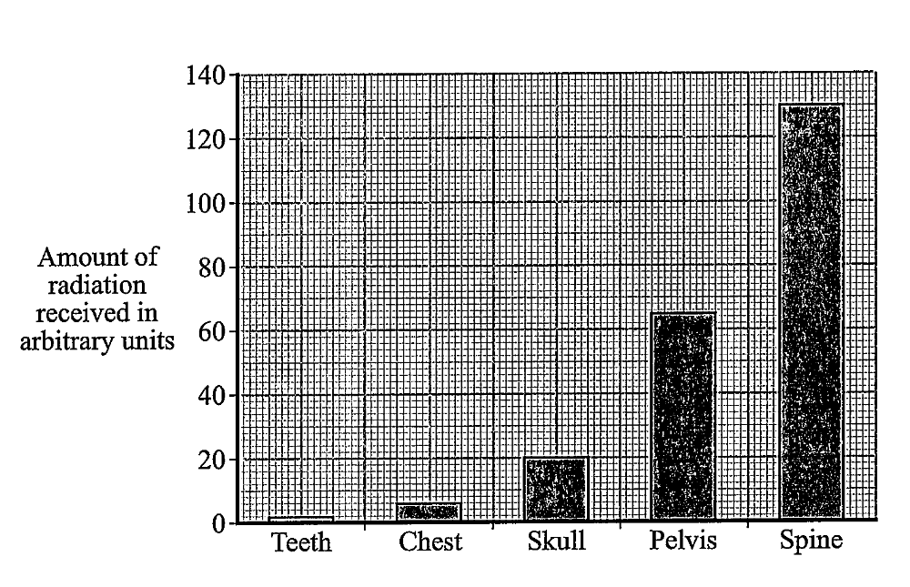
The graph below shows the amount of radiation received by the body when different parts of the body are X-rayed. This data was collected from a population of 200 patients.

  - State the independent and dependent variables for this experiment
(2 marks)
    - Independent: __________________________________________________

    - Dependent: ___________________________________________________

  - State two variables that would need to be controlled when collecting this data.
(2 marks)

  - What would be an appropriate title for the graph?
(2 marks)

  - List one way in which the data collected could be more reliable.
- mark)

  - What unit of measurement would you choose to place on the y-axis? Explain your choice.
(3 marks)

  - Suggest a reason why the total radiation received by the patient’s body is high when the spine is being imaged and small when the patient’s teeth are being imaged.
(2 marks)

END OF TEST

